Sheen Kim
Professor Alvarez Leon
GEOG 58: Critical Analysis in GIS
7 June 2021
Final Project: Alternative, Individual Mapping of War

- Introduction

Critical and feminist GIS scholars maintain that the tools of a GIS can be appropriated to represent alternative ontologies and identities. As knowledge is always partial and situated, it falls on us to give proper credence to subaltern voices and notions of space in our GIS.
One such subaltern that it is necessary to focus on is everyday peoples in war, given continued militarism, imperialism, and neocolonialism across the globe. In this research project, I set out to explore two questions through a series of five visualizations of the life of Chun Suntae, a Korean survivor of the war.
- How, or can, one map the very human aspects of war?
- In telling one of infinite individual stories of war, what is privileged and prioritized? What is forgotten?
There is no singular map that can encapsulate and deliver the full trauma of any war. Yet, there are myriads of strategies that we can use to show that lives are at stake. War cannot be restricted to or visualized solely as a masculinist “numbers game” that prioritizes technology and powerful actors over very real deaths and trauma. As Colin Dickey writes, discussions of war tethered by “an obsession with Steve Jobs-esque ‘innovators’ and ‘disrupters’ leads to a tunnel vision and moral vacuity” (Dickey 2021).
My intentionality echoes those of the survivors of war −that war must end, that Koreans must be allowed to see each other, that conflict without regard for human life will lead to the end of us all.

- Historical Context

The Korean War, also known as the “Forgotten War,” has largely disappeared from the American psyche−despite its allowance for the continuation of U.S. military presence and hegemony in East Asia, maintenance of Korean separation, and kickstarting of a modern legacy of anti-communism and silent deliverance of death to indigenous peoples all cross the world. Yet, in popular media and geopolitical discussions, Korea is often referred to only in terms of power and political maneuvering, with little conversation about those fighting to receive the resolution that they deserve. “For me,” one child of a survivor describes, “it is not the past. It carries forward into my life. It carries forwards into my sisters’ lives… as a hole” (Ahn 2009, 11).
Chun Suntae was a survivor of the Korean War born in Kaesong, in what is now in North Korea. I chose his story because he best represents the blocks to mobility, the adjacency to death, the trauma from bombing, the separation from family, and the forced displacement that so many Koreans have also experienced.

- Visualization Discussion

The following five visualizations represent various methods of mapping with different
prioritizations and privileges−although all aim to represent Chun Suntae, and the Korean War, by extension, with as much respect and agency as possible. I ask what is cartographically-embedded in each of my visualizations, my own positionality, and the balance of context, spatiality, and dangers of doing so. Once again, what is privileged? What is forgotten in our discussions of “dimensions of marginalization and exclusion”? (Kwan and Schwanen 2012, 2043).

Map 1: Exhibition (PDF Link) (Created in Google Slides, Procreate, and Clip Studio Paint).

My first map (see PDF) prioritizes narrative, movement, and broad perspective. This map draws inspiration from museums/exhibits and storymaps that merge narrative with cartography. A map blocking out where Chun exerts everyday mobility at a given moment in time in red is displayed alongside explanatory texts and photos of that time to provide perspective.
This map, unlike the others, provides Chun’s full story alongside the map. I manipulate what Harley calls an “internal power” in cartography, prioritizing broad shapes over the minute political details so valuable to the state (1992). Alongside the narrative, Chun’s own words and photos of destruction augment the map (and vice versa). It is important to note that while Chun’s perspective is meant to be at the forefront, Chun, or any such survivor, is denied the overhead view that this map and others provide. People instead understand space around them, something that the broad shape hopes to replicate.
The main limitations here are space due to the curatorial nature of the map and the lack of visualization of real mobility as opposed to possible mobility−it is an abstraction. Visualizations of this kind also most risk turning experiences into spectacle rather than experiences to be learned from and may falsely create a separation of the map from the historical substance.
Figure 1: GIF of Chun’s motion, showing a decrease from the entirety of Korea, to eventually only the two brief points in the DPRK.

Map 2: Grief-Flow Map (Created in Procreate)

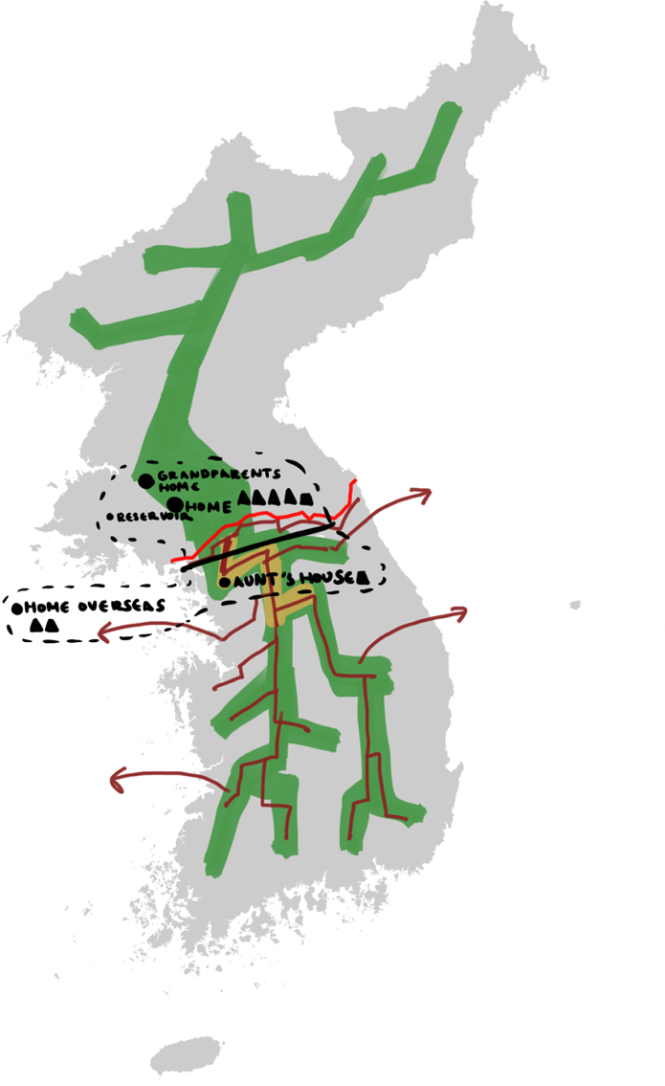
This map shows Chun’s mobility through colored flows, overlaid with a grief map inspired by Maddrell (2016). It prioritizes movement and space over direct narrative or perspective and is a form of “alternative cartographic practice” (Kwan 2010, 649).
In this map, Korea is stripped bare of any specific place names and city boundaries, save for its boundary in the north. Specific cities are collapsed into the flow, asking what such boundaries and sudden blockages to mobility mean to people who have lived in a place for all their lives.
This map tests visualizing narrative of movement without a reliance on unwieldy text, demonstrates representation of the body through a flow line. The grief maps serve to show the “impact of bereavement on dynamic experiential place-temporalities”; sites of Chun’s separation from his loved ones (Maddrell 2016, 183). This map does, however, require an understanding of the divide and of Chun’s location in Kaesong, and works best alongside context.
Margaret Pearce argues place as “what a person has undergone or suffered” (2013). But in this map, I seek to visualize that space travels with one person, and even when the map is devoid of “experience” in the conventional sense (text, photos, “artifacts”), movement is experience.
Figure 2: Grief-Flow Map. The green represents Chun's flows pre-divide, the yellow represents movement during the conflict, and the red after the conflict and solidification of the divide (shown in the bright red line). Overlaid in black is a drawn grief map that shows important locations to Chun, where the triangles represent people.

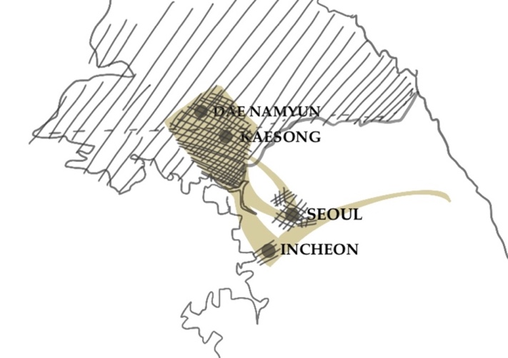
Map 3: Flows and Shapes (Created in Procreate)
Figure 3 : Flow map showing length of time and affect. Wider flows are where more time, family, and affect are spent/created.
Figure 4: Dark circles added to representing conflict/mass
death/bombings, with annotations added for context.

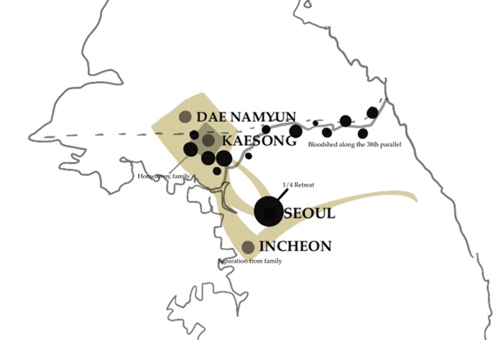
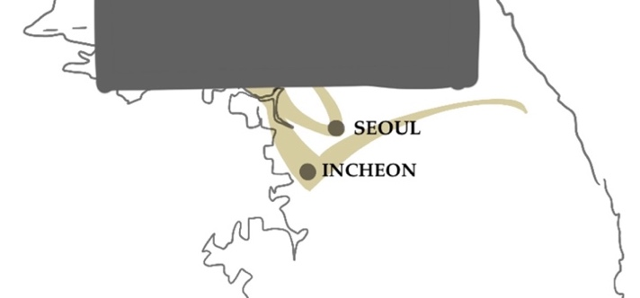
Figure 5: Addition to Figure 3, where hachured lines are added to show trauma (with concentrated lines representing more trauma).

Figure 6: Figure 6: Blocking off the North for visual shock (they can no longer return).

This is a set of four visual flow maps modeled after Charles Minard’s classic flow map Napoleon’s March to Moscow, with narrative elements inspired by Meghan Kelley’s Eritrean Human Trafficking Project. Unlike Maps 1 and 2, these maps prioritize less the temporal aspect of Chun’s movement, and instead focus on movement, trauma, and death. Shapes are used to represent neglected elements. This is my most visually uncluttered representation of Chun’s experience, but offers a variety of ways in which to demonstrate trauma, travel, and past/present movement. Brown and Larry discuss the inherent governmentality of geovisualizations that use government-created blocs of space such as census blocks or towns (Brown and Larry 2006). What, then, if we choose to combat this counting and display experience beyond numerical data? While cities and borders may tether us into an assumption that such things are fixed, abstract shapes and depictions can show their ability to be changed inasmuch as they show how people replicate or subvert governmentality (and warmongering, as a result). The individual continues to be at the center here.

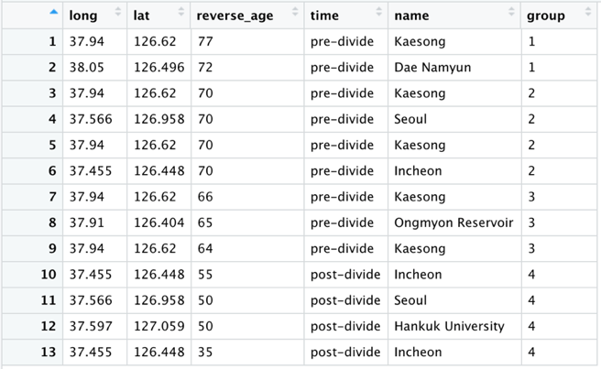
Map 4: Minard Flow Map (CSV download, R file download) (Created in Microsoft Excel, R)
Figure 8 Spreadsheet used to create visualization.
This map is also inspired by the same Minard map as the above, but this map uses traditional GIS methods through the normal point-raster system in R. This map prioritizes flow, shape, and accessibility over narrative and creative visualization, showing plainly how Chun was able to move and was then restricted. Alongside this visualization, however, comes concerns normal to GIS analysis. Rather, it asks of Chun’s movement can truly be represented through points and lines alone, and if a coordinate system can truly show the range of emotions. It is also important to note that this spreadsheet is an arbitrary creation based on vaguely where Chun [theoretically] would have access to/frequently traveled, and thus challenges my own positionality and knowledge into a someone else’s life. However, this display has power in its starkness and cleanliness, showing clearly cut off movement.
Figure 7: Minard GIS created in R with GGPlot. Code/spreadsheet analysis is available in the R file. The thickness of the lines denotes Chun’s age/time, or what is referred to as “reverse_age,”or years from death(as he leaves his home and is restricted to the South, so too he loses that much time. See code for more comments.
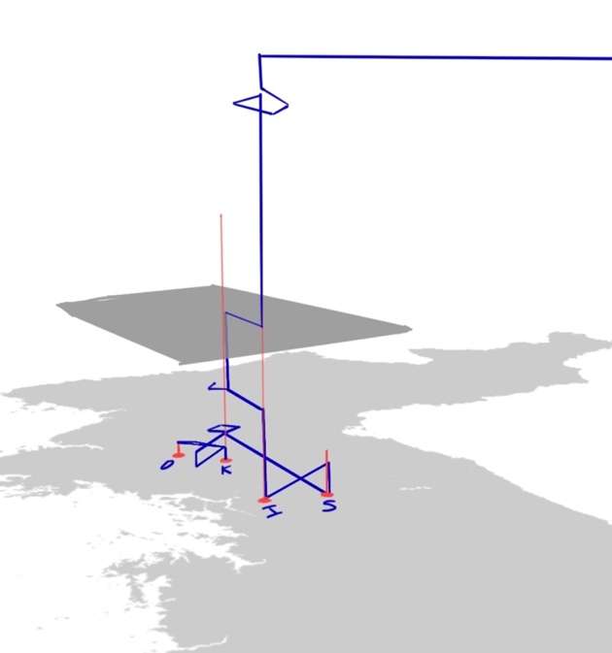
Map 5: Space-Time Paths (Created in Procreate)

This map, modeled after Mei Po Kwan’s space time paths, focuses on temporality and movement, alongside a non-overhead perspective. It asks what it means to understand movement in a 3D space through lines. Mei Po Kwan asks how such lines can be “reimagined as body inscriptions−inscriptions of oppressive power relations on women’s everyday spatiality” (2002, 653). While Chun is male, such lines nonetheless can show how the power relations of imperialist war and daily violence can limit everyone’s spatiality (and also suggests the buried voices of women in the war). This specific display challenges and appropriates GIS and lines.
Figure 9: Space-Time Path of Chun, where D = Dae Namyun, K = Kaesong, I = Incheon, S = Seoul. The 3D black plane represents the divide, and the blue lines represent Chun’s movement (with time along the Z-axis). The red lines are provided for alignment.

- Conclusion

I return to my research questions:
- How, or can, one map the very human aspects of war?
- In telling one of infinite individual stories of war, what is privileged and prioritized? What is forgotten?
There are infinite ways in which to map the very human aspects of war to exemplify the destruction and limitations that such wars bring; my usage of flow lines, 3D perspectives, space-time lines, shapes, hachuring, and accompanying text were but a few available tools. While visualizations may privilege certain aspects of the individual experience over others, depending on the cartographers’ decisions (narrative over mobility, flows over perspective, etc.), and may forget other subaltern identities at such a small scale, they hold great possibility for amplification.
As Pavlovskaya notes, critical GIS can and must be a tool for social transformation. Maps are powerful and empowering practices that “produce the worlds instead of simply reflecting”(2018). The “instead of” here is not an implication that production must be valued over reflection; a map must do both. I hope my visualizations show possible ways to reflect those who must be prioritized in war and in life: the people. It is only then can we move onto the production of worlds: ones where indigenous people maintain sovereignty over their land and Chun Suntae and other families would have been able to live with their families before their death.
Cartography using a variety of critical, and feminist methods cannot and should not stand on its own and must be put to use. Inasmuch as they create new ways of thinking, destruction is happening and continues to happen. We must put cartography into action. I plan to further refine and explore more visualizations, beginning with Map 3, and submit them to the growing body of work against imperialist war and occupation all over the world to aid activist groups and grassroots organizations. Critical, creative ways of mapping alone will not save us, but the understandings that they foster will−alongside sustained effort and action.

- References (and Image Sources)

6월 4주│6·25전쟁, UN군 6·25전쟁 참전 결정. (n.d.). 네이버 블로그 | 국방정신전력원 블로그. Retrieved June 7, 2021, from https://blog.naver.com/jungsin3560/221034858082
15 old photos of North Korea in the 1980s. We were indeed not as good as others. - INEWS. (n.d.). Retrieved June 7, 2021, from https://inf.news/en/history/d0d0f33fdd9f30dd8ee877530300aae3.html
64 years after Korean War, North still digging up bombs. (2021, April 22). AP NEWS. https://apnews.com/article/international-news-asia-pacific-ap-top-news-north-korea-dd6256bad51e458cb2e8a1bf64b5c2b6
1930년 전후의 개성 주택가. (n.d.). 네이버 블로그 | Bookhunter. Retrieved June 7, 2021, from https://blog.naver.com/bookhunt/110189425408
1950년 인천항에 정박한 연합군 전차상륙함. (n.d.). Retrieved June 7, 2021, from https://news.naver.com/main/read.nhn?mode=LSD&mid=sec&oid=001&aid=0008697096&sid1=001
1951 Korean War Peace Talks. Kaesong, Korea. (n.d.). MilitaryImages.Net. Retrieved June 7, 2021, from https://www.militaryimages.net/media/1951-korean-war-peace-talks-kaesong-korea.113891/
Ahn, C. (2019). Disrupting War: Women Cross the Korean DMZ. American Quarterly, 71(4), 1045–1052. https://doi.org/10.1353/aq.2019.0075
Beatnavy90. (1950). English: These are P-51 Mustangs from the US Air Force 8th Fighter Bomber Group at Kimpo Airfield, also known as K14, in October of 1950. Photo taken by LTC (USAF Ret) Harvey W. Gipple. Own work. https://commons.wikimedia.org/wiki/File:F51s_K14_Kimpo_Airfield_Korea_Oct_1950.jpg
Brinch, S. (2019, March 22). Charles-Joseph Minard’s map of Napoleon’s flawed Russian campaign: An ever-current classic. https://sciencenorway.no/a/1618695
Brown, M., & Knopp, L. (2006). Places or polygons? Governmentality, scale, and the census in the Gay and Lesbian Atlas. Population, Space and Place, 12(4), 223–242. https://doi.org/10.1002/psp.410
Camp Market—Incheon. (n.d.). Retrieved June 7, 2021, from http://wikimapia.org/21329642/Camp-Market#/photo/3663441
Chen, J. K. (n.d.). MILK COUNTRY. Retrieved June 7, 2021, from https://www.janicekchen.com/vermont/
Cho, G. M. (2008). Haunting the Korean Diaspora [Book]. University of Minnesota Press. https://www.upress.umn.edu/book-division/books/haunting-the-korean-diaspora
Data—The GIS of War—Tracking Conflicts and Their Effects. (n.d.). Geographic Information Systems Stack Exchange. Retrieved June 7, 2021, from https://gis.stackexchange.com/questions/7758/the-gis-of-war-tracking-conflicts-and-their-effects
Dickey, Colin. (2021). Twitter. https://twitter.com/colindickey/status/1400801923264139269.
Ellis Act Evictions, San Francisco—Anti-Eviction Mapping Project. (n.d.). Retrieved June 7, 2021, from http://www.antievictionmappingproject.net/ellis.html
File:San Francisco—Chinatown 1965.jpg—Wikipedia. (n.d.). Retrieved June 7, 2021, from https://commons.wikimedia.org/wiki/File:San_Francisco_-_Chinatown_1965.jpg
Harley, J. B. (1989). Deconstructing the map. Cartographica: The International Journal for Geographic Information and Geovisualization, 26, 1–20.
Hiroshima Peace Memorial Museum. (n.d.). Retrieved June 7, 2021, from http://hpmmuseum.jp/?lang=eng
KAESONG, KOREA 1950-06. TWO NORTH KOREAN SOLDIERS NEAR KAESONG ON THE 38TH PARALLEL. (DONOR: F. ... (n.d.). Retrieved June 7, 2021, from //www.awm.gov.au/collection/C43439
KAESONG, KOREA 1950-06. VIEW FROM A HILL ON THE 38TH PARALLEL. (DONOR: F. PEACH). (n.d.). Retrieved June 7, 2021, from //www.awm.gov.au/collection/C43441
Kaesong Tea House. (n.d.). Retrieved June 7, 2021, from http://public1.nhhcaws.local/our-collections/art/travelling-exhibits/remembering-the-forgotten-war-korea-1950-1953/kaesong-tea-house.html
Katz, C. (2001). Vagabond Capitalism and the Necessity of Social Reproduction. Antipode, 33(4), 709–728. https://doi.org/10.1111/1467-8330.00207
Kelly, M. (n.d.). Eritrean Human Trafficking Project. Meghan Kelly Cartography. Retrieved June 7, 2021, from https://meghankelly-cartography.github.io/HumanTraffickingMinard.html
Korean War—Back to the 38th parallel. (n.d.). Encyclopedia Britannica. Retrieved June 7, 2021, from https://www.britannica.com/event/Korean-War
Kwan, Mei-Po. (2002). Feminist Visualization: Re-envisioning GIS as a Method in Feminist Geographic Research. Annals of the Association of American Geographers, 92(4), 645–661. https://doi.org/10.1111/1467-8306.00309
Kwan, Mei-Po. (2016). Mei-Po Kwan’s 3D GIS work—Space-time paths. http://meipokwan.org/Gallery/STPaths.htm
Kwan, Mei-Po. (2002). Feminist Visualization: Re-envisioning GIS as a Method in Feminist Geographic Research. Annals of the Association of American Geographers, 92(4), 645–661. https://doi.org/10.1111/1467-8306.00309
Lee, E., & Lee, P. K. (n.d.). 70 Years of Separation: The Families Who Remain Divided by the Korean War. Retrieved June 7, 2021, from https://thediplomat.com/2020/06/70-years-of-separation-the-families-who-remain-divided-by-the-korean-war/
Liem, D. B., Liem, R., Kim, H. B., Chun, S., Park, K., Lee, M., Cumings, B., & Yuh, J.-Y. (2013). Memory of forgotten war. Mu Films and The Channing & Popai Liem Education Foundation.
Liem, Ramsay. “When a Fireball Drops in Your Hole: Biography Forged in the Crucible of War.” Koreans in America: History, Culture and Identity. Ed. Grace Yoo. San Diego, CA: Cognella Academic Publishing, 2012. 271-292.
Maddrell, A. (2015). Mapping grief. A conceptual framework for understanding the spatial dimensions of bereavement, mourning and remembrance. Social & Cultural Geography, 17, 1–23. https://doi.org/10.1080/14649365.2015.1075579
Mountz, A., Coddington, K., Catania, R. T., & Loyd, J. M. (2013). Conceptualizing detention: Mobility, containment, bordering, and exclusion. Progress in Human Geography, 37(4), 522–541. https://doi.org/10.1177/0309132512460903
Pavlovskaya, M. (2018). Critical GIS as a tool for social transformation. The Canadian Geographer / Le Géographe Canadien, 62(1), 40–54. https://doi.org/10.1111/cag.12438
SCHWANEN, T., & KWAN, M.-P. (2012). Critical space–time geographies. Environment and Planning. A, 44(9), 2043–2118.
Suntae Chun. (2015, August 22). Legacies of the Korean War. https://legaciesofthekoreanwar.org/story/suntae-chun/
Suntae Chun (1939-2017)—Find A Grave Memorial. (n.d.). Retrieved June 7, 2021, from https://www.findagrave.com/memorial/205297008/suntae-chun
The Korean War: Barbarism Unleashed. (n.d.). Peace History. Retrieved June 7, 2021, from http://peacehistory-usfp.org/korean-war/
Under a Mushroom Cloud | Japanese American National Museum. (n.d.). Retrieved June 7, 2021, from https://www.janm.org/exhibits/under-a-mushroom-cloud
Where North and South Korea Meet. (2018, April 27). Wall Street Journal. https://www.wsj.com/articles/where-north-and-south-korea-meet-1524782494
Young, Marilyn B. (2001). Korea: The Post-War War. History Workshop Journal 51, 112-126.
고병준. (2020, June 24). Seoul severely destroyed during Korean War. Yonhap News Agency. https://en.yna.co.kr/view/PYH20200624045700325
성두경 탄생 100주년 기념전, 잃어버린 도시, 서울 1950-1960s. (n.d.). 네이버 블로그 | 포토닷. Retrieved June 7, 2021, from https://blog.naver.com/photodotb/220523093175

- Appendix

A. Chun Suntae’s Full Story
Items in bold are general historical events.

# | Date (approx) | Location | Description
1 | 9/9/1939 | Kaesong | Chun Suntae (Suntae Chun) was born into a family of the eldests; his grandfather was the eldest; his father was the eldest; he’s the eldest. (If his grandfather was king, he jokes, he would be king too.)
2 | 1945 | 38th Parallel | “In 1945, on the eve of Japan's surrender to the United States, rather than liberate Korea, which had been colonized for thirty-five years by Japan, two young military officers were assigned by the US State and War Departments to divide Korea. The two officers tore out a map from National Geographic and literally drew a line across the thirty-eighth parallel because it placed Seoul in the US zone. President Harry S. Truman sent a memo to Joseph Stalin informing him that the Soviets could take Pyongyang and the area north of the thirty-eighth parallel, and that the US would take Seoul and the region south of it. It is through this arbitrary, imperial border-making process that Korea became divided over seventy years ago and still remains divided.” (Ahn 2019, 1045)
3 | Until 1947-1948 | Border area | Chun notes how they enjoyed relatively free movement throughout the peninsula during this brief time of post-Japanese occupation; ex. his grandparents lived in the city of Dae Namyun, so he and his family would travel back and forth between Dae Namyun and Kaesong, as would other Koreans and small merchants.
4 | 1948-1950 | All throughout Korea | Southern U.S. military occupation - U.S. suppressing strong left wing organizations throughout Korea - occupation thought there was a revolutionary situation - rehired the police and military figures (Koreans who had served the Japanese) + 1948 - Syngman Rhee v. DPRK September 1948 - building of fortifications along the 38th parallel - 1948-1950, frequent battles along the parallel - both Koreans wanted a forceful reunification (also the establishment of the National Security Law in Korea - which forbid any sympathy toward the DPRK)
5 | ~1948-1950 | Kaesong | Kaesong was right below the parallel (“like a backyard”) - Chun notes the many small wars in his neighborhood, where a friend and classmate was killed.
6 | June 24, 1950 | Ongmyon/Kaesong | Chun, a member of his high school swimming team at the time, went to picnic with his team at the Ongmyon Reservoir, when war broke out the next day - they woke up to machine gun fires and mortar fires. This was right when the DPRK Army passed the 38th parallel and began their rush down into the South. The team returned to Kaesong and saw the soldiers as a group; the DPRK soldiers told them that Kaesong is occupied and liberated. Chun remembers the corpses - of Koreans, of police officers.
7 | Late 1950 | Throughout Korea | The U.S. and UN forces begin their own armed opposition led by General MacArthur. After the initial rush that Chun describes, Korean civilians retreated with U.S. soldiers. UN forces land in Busan and launch an amphibious invasion in Seoul. After the Incheon landing, the KPA retreated North and the US Army occupies Seoul (a time accompanied with brutality against any DPRK sympathizers). The ROK forces eventually reach the the Yalu River in 10/27/1950, before the Chinese Peoples’ Army came to the DPRK’s aid in 11/3/1950, where the DPRK and CPA then occupied Seoul.
8 | 1/4/1951 | Seoul/Kaesong(?) | The 1.4 Retreat, allso most known as the greatest cause for Korean displacement. The Air Force was told to take out any village that might have DPRK troops with napalm and incendiaries—population center Seoul included. Chun stayed in Seoul, noting how “If you stay there, you’re gonna die by American bombing.” “I can still hear the sounds… Right after, there’s an orange fire… comes right next.” “North Korean army keep teaching us don’t run, don’t run, when the planes show up suddenly, just sit down there or lie down. Stand still or lay down, don’t move.” “I think I survived because of that lesson. But older people don’t know, they just keep running to their home. They run. And airplanes spot them. And come down and shoot them.” Chun details how elders and civilians were actively killed by airplanes and kept raining down destruction. Americans just keep killing people, napalm.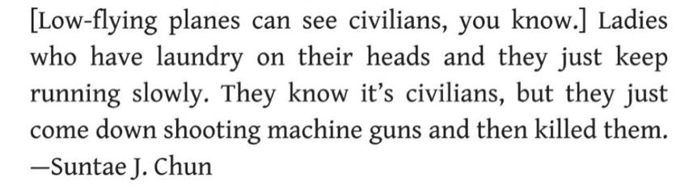  Chun describes how, as soon as they landed safely, they went to the church - grassland fields + airfield - a priest.. father with a robe comes out and welcoemd the soldiers, kneeled down; “What is God and church and priest and bombing all related? What kind of answer? I didn’t have any answer at the time. Just a strange feeling. So after that I said I never go to church again.”  “After I went to Seoul, I saw lots of churches again. Every corner had churches. You know why? There’s a lot of fraud. Lots of bad guys put on a white collar and then found someone who spoke just a little English and took him to any GI camp. They’d say, “I’m a minister. I have a lot of orphans around here. I need your help. I’m going to build a church.” Next day five, ten truckloads of two by fours and tents, everything comes in. Then he goes back there again: “I need some food.” But most of them are frauds. All that money for churches and orphanages and still people are dying, but some people got richer and richer. They just used two pennies out of ten cents for the kids and put the rest in their pocket. So, so, so stupid. But that’s the way it was.”
9 | 3/1951 | Seoul | UN Forces recapture Seoul after the 1.4 Retreat.
10 | Between 3/1951-7/1951 | Kaesong | Chun describes how forces were in and out of Kaesong - the ROK would occupy it for a week, then the DPRK would come back, and then repeat. Chun’s father went down to Incheon with the Korean Army one of these times, and Chun went down 15 days later to follow him, but his relatives told him that his father had left three days earlier for Kaesong. This marks the last time that Chun saw his father.  “Another big problem was everything was destroyed and it was even hard to find wood for burning to cook. So, one day I found an unexploded napalm casing [and took it to our tunnel] and there’s a big hole in the bottom. So I hit the ground with the canister and sticky stuff kept coming down. If you have just one small piece, you can make rice with it. It’s that strong fire. I kept hitting the casing and suddenly it exploded right in front of me, shrapnel through my cheek and burning me! There’s a small hole at the other side of our tunnel and I put my mouth in the hole and yelled, “Help me, help me!” And then I passed out. When my father came, I still remember he was mad. There was also an old lady near the tunnel. Instead of coming to me, he went to the old lady to make sure she was ok [laughs]. Then, after that, he came to me.”
11 | ~7/10/1951 | Peace talks start in Kaesong | Kaesong was cordoned off, blocking movement in and out of the city. During this time, the border was solidified. Chun says, “I cried about a couple of months every night.” During vicious trench warfare along the 38th parallel, Chun was effectively cut off from his family, his home, and had nothing with him due to a trip down. As the peace talks continued, there was continued armed fighting at the border.
12 | ~sometime around this time | Incheon | Chun describes how he had to get a job. The only jobs available were at the U.S. army base - seeing GIs, and worked about there a month or two for a small sack of rice.  “I was staying with my aunt, the policewoman, in Incheon, but she was all alone, too. After about two months, I needed to make money for food so I start working. It’s the first time I ever worked. She found it for me at Incheon High School called Jemulpo. It was empty, used for temporary stays. American soldiers going to the front or coming back stay there couple of days, shipping out to the United States or the south, and then coming back, like that. All the classrooms become bedrooms for GIs, and some Koreans run their KP, kitchen. A lot of Koreans were doing that, and I envied them so much. Those guys get to eat some meat and Coca-Cola. That’s first time I tasted it, bottled Coca-Cola [laughs]. My job was to put wood in big straw bags, two by fours. Schools always had this big field with no grass, nothing, just all sand. So I circled around dragging this big bag so it’s nice looking. I don’t remember how much I got paid. I think they gave me rice, a little bit, each day. I was the youngest worker. Everyone else was a refugee with wife and children left behind.”  “There’s a funny story at this time. This sergeant always hit and kicked the old people doing manual work, using bad words—“son of a bitch.” The KP guys always gave us something to eat instead of throwing it into the garbage—leftovers. We told them, “That guy, he just hates Koreans.” So one day, the KP guy says, “Let’s do something about it.” I still remember. It was very funny. At that time, no one has shampoo so everybody has dandruff. He put big dish of food together for him and then one of the other guys with a lot of dandruff put a lot of dandruff in the food. You cannot see it, right. So, this guy eats it. The next day – there’s a bathroom right in one corner of the field—this guy was almost sleeping there. He couldn’t get out. He’s got, what do you call it, seolsa, diarrhea! I mean, he just stayed there. After a few days I heard he was transferred to some hospital. And I’m glad we did it. Really. Some guys were nice, fair. But that guy, somehow he’s got all the anger, especially at people, you know, just like my father; he kicked their butts all the time. “Son of a bitch, motherfucker,” like that. I hated it; everybody hated it. So we did it that way.”
13 | 7/27/1953 | Kaesong | US, DPRK, China signed, but not the ROK - the division between North and South became permanent, and so families who were in the North and South at the time became separated. “Yeah, war is over. I know. But it does not help much because I cannot go back.” After three years, the border had been redrawn to include Kaesong, which suddenly became a part of NK - having not only the physical effect that folks could not return and were irreversibly separated from their families, but also that they would have communist suspicion cast upon them.
14 | Sometime after | Hankuk University of Foreign Studies (Seoul) | Chun was only thinking about living despite all this familial destruction - “Where to sleep? What to do?” He eventually went to school @ Hanguk University and became friends with other folks who had dispersed families - he tried to be a diplomat, but realized “that’s a really stupid idea.”  “The war is quite different. Korean War time, life is so cheap, very cheap. You’re under bombing everyday. You just become animal. You’re always wondering where you’re gonna hide. And when they start bombing, suddenly friends you met an hour ago are dead. Everyday is like that. But at the time, I didn’t have time to mourn or cry for a friend. I have to think about my surviving because I don’t know when I’m gonna die. So, no time to mourn. I mean, so, so stupid. But somehow, your survival instinct is very strong. Very close to me, a bomb exploded one time. You cannot hear anymore for a while and you think you will die and you feel like all kinds of shrapnel are in your body. Since that time, almost everyday, both my eardrums just blocked and you cannot hear outside sounds. A minute and then it’s gone. That lasts for thirty, forty, fifty years.”  “But one thing, whoever experiences all those violent, unnecessary deaths, somehow the psychology becomes more negative. It’s fading away as time goes by, but I think people who experience dead bodies and bombing and killing and life is so cheap and you don’t know when you’re going to die and when your friends die—it’s sort of, life is kind of pessimistic. You don’t think about it, but deep inside, just, I might die suddenly. I’m not going to live a normal seventy, eighty years old life. Deep inside, I just feel that. Just overall, life is kind of not for happiness. It leaves the heart.”
15 | 1965 | Move to the US | He quickly faced barriers because the ROK did not like refugees who had any family in the DPRK at all, and so he couldn’t get a job, couldn’t get further education, could not join the West Point - because they didn’t give him anything, he decided to immigrate to the US in 1965, driving him further from his homeland.  “Everybody at the time was dreaming about the United States. You saw the giant movie, you know, Rock Hudson, or James Dean in a red sports car and then in a restaurant, coffee shop, the guy standing over the sink slowly washing dishes. That’s what I thought a restaurant looked like. That’s easy work and somebody said, “Hey, if you’re driving trucks, you can make over ten dollars per hour.” I thought all those things. When I came here, it was just totally a different story! I had friends living here, five guys in one room, just like farm workers.  San Francisco is a tourist city. So all the jobs available to foreign students are either hotel or restaurant. You’re either dishwashing or night cleaning or bus boy or waiter or bellboy. So that’s where I got a job and went to school. I went to San Francisco State, undergraduate, and after that I switched to economics in graduate school. I almost finished, about couple of courses left. But it was 1971 near the end of the Vietnam War. There’s no jobs. One guy I remember was a chemist, Ph.D. He sent applications all over the place and all returned, “I’m sorry, we don’t need you.”  So I thought, “I’m getting older. Gee, if I got a degree, so what?” Then somebody said, “There’s a small business administration in the federal government, and they can give you a guaranteed loan.” So, I applied. I found a business, a liquor store. He’s asking $50,000. I applied to Crocker Bank. I still remember this guy, vice president, and he said, “Well, you have a problem because you’re single, you don’t have any experience, and you don’t have any assets.” “Well, if I have assets, I don’t come to you. Single, I cannot help it. Well, experience, hey, if every time you start something, you need experience first, well….” Then I found his secretary and asked her, “Hey, is that guy single or married?” She said he’s divorced. So the next time I meet him I say, “Are you married?” He says, “Yeah, I was, but I’m single now.” “So, I’m single too.” I asked him, “Do you have a problem finding a job as a vice president because you’re single?” He said, “No, I don’t have problem.” “So, then why worry about that, being single?” So, one by one like that, and he finally gave me the loan. So I took over the liquor store, stayed about three or four years.”  “Sometimes, just driving around with my wife and kids, one daughter says, “Appa, I was curious, how was the war like? What did you do before the war?” When I start talking, it’s not easy. You cannot just say, “I was okay.” So, at the time I said, “This and this and then colonization by Japan.” Just little by little, liberation and then GIs come in. Then about 30 seconds, maybe 20 seconds, they change the subject. (laughs) So, I say, “Hey, don’t ask questions like that anymore if you guys are not interested. I’m not just making a long story for nothing. You have to have some background, a little bit.” But they cannot wait, about 10 seconds, 15 seconds, they say, “Hey, look at that outside!”
16 | 1981 | Reuniting in Pyongyang | Suntae Chun was able to reunite with his mother, brothers, and sisters in 1981; although he found out that his father had died in 1964 from pneumonia.
* 17 | - | - | Chun notes at the time of the filming of the documentary (2013) that a divided Korea still exists. Still seperated families - still cannot see each other for 60 years - “Sixty years, still cannot see each other. We have to correct that” - took Korean American separated families to North Korea and let them meet their families there. Mr. Chun took Korean families to the North every month for three years took up to 35 families.  “Young kids growing up in the United States without any war experience are different. But my age Korean people are more enduring. More, what do you call it, like a bulldozer type. A lot of people are talkers, thinking this way, that way. But we cannot think of all those things; just do the job. War is like that. It just pushes you; pushing, pushing to do something to survive. Koreans are like that type.  But it’s hardships, too, after the Korean War. The sixties were very poor [in South Korea] so you have to struggle and competition is high. So they study always hard. Push hard, hard to study. So, that hard life from generation to generation, and occupied by outside people and fighting back all the time with China and Japan and Russia and then the United States, years and years and years—I think all those things make Koreans a little bit of a cement type. Cement. Rough type.  I know a guy, works very hard, seven days a week. He’s 47-year-old guy and even if he does not know how to do [some part of his work], he just keeps going. I just look at him and it’s amazing. I’m nothing compared to him, but a long time ago I had a body shop and I don’t know anything about mechanical things and how to assemble the car. They have a carburetor. Carburetor is so complicated. I pull it out and take it apart, put newspapers here and there, and finally I take apart everything, clean it, and put it back. I have a few things left over and I don’t know where it goes. Finally, I give in. I spend a lot of money for somebody to fix it. No, no, it doesn’t work all the time but sometimes I make it!”  Suntae Chun passed away in San Mateo County in California on June 21, 2017.

B. Grief maps (Maddrell, 2016, 182-183).
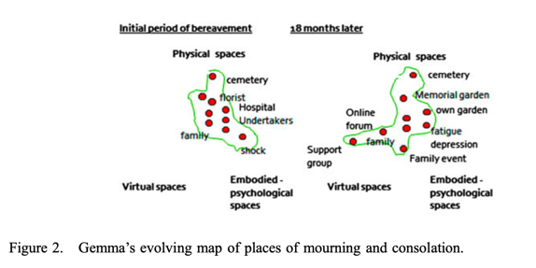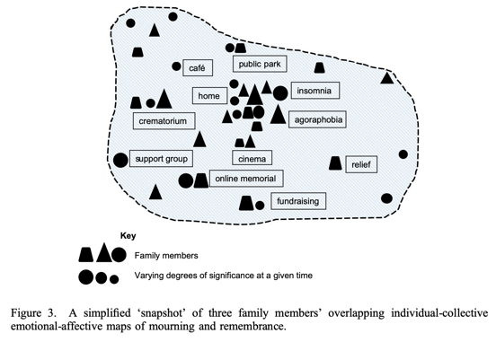

C. Rough sketches/storyboards
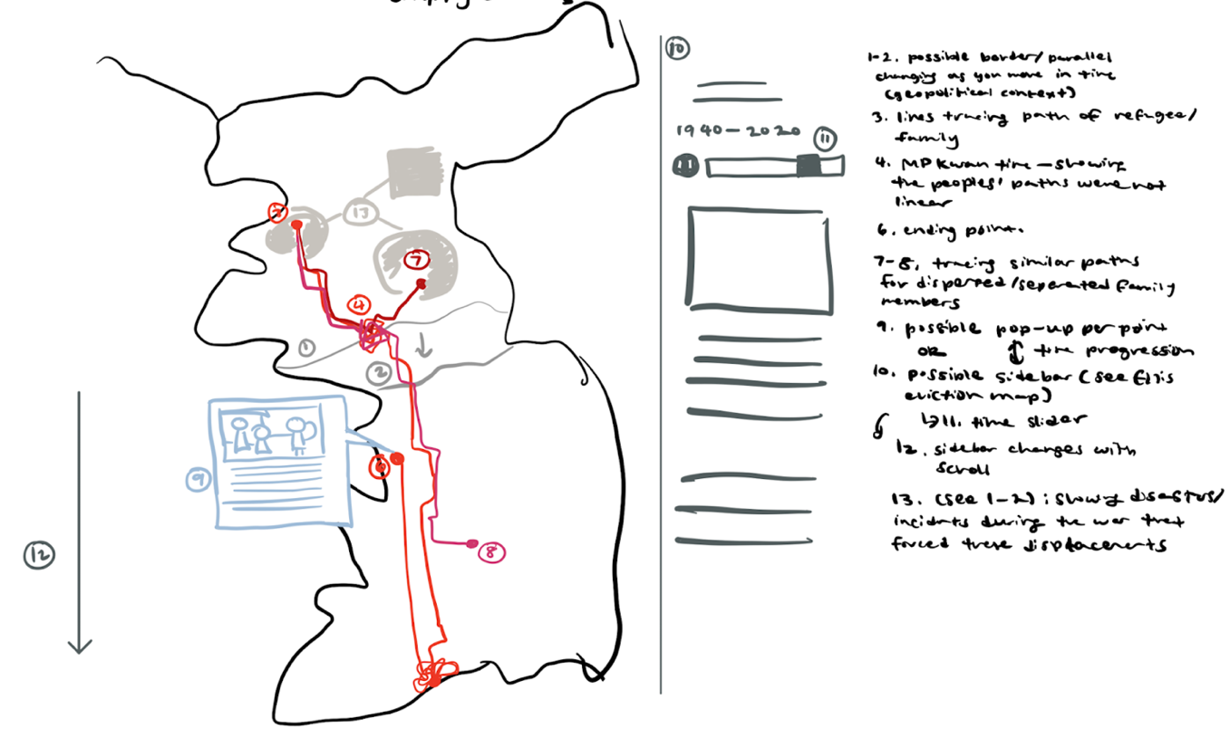
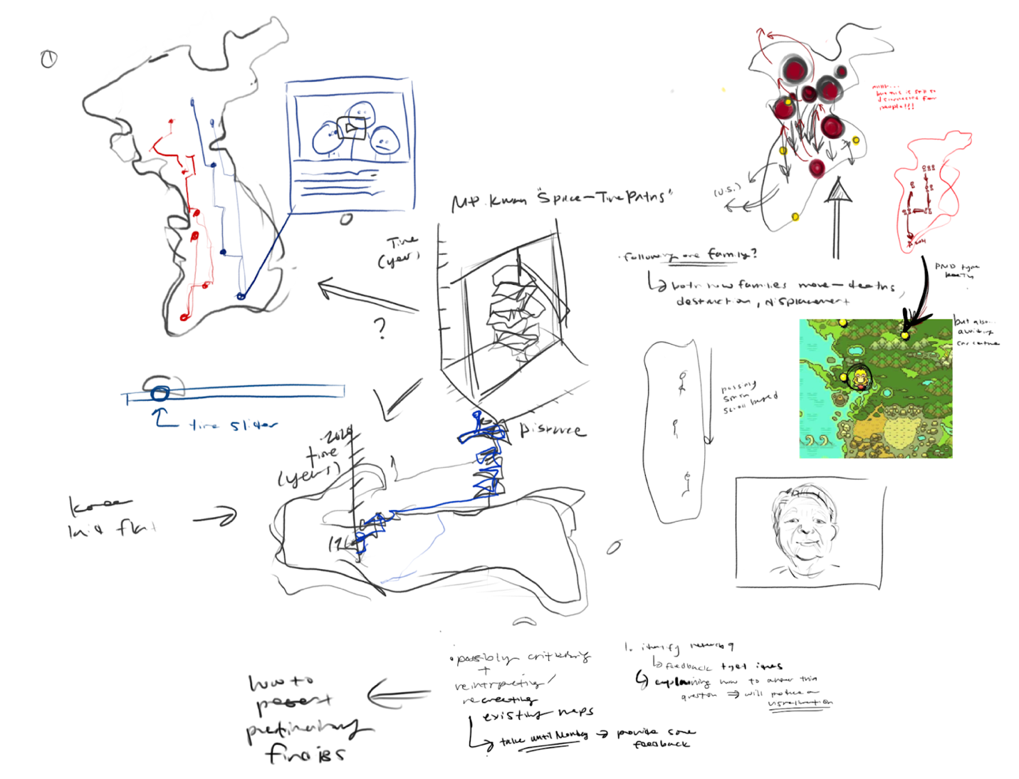
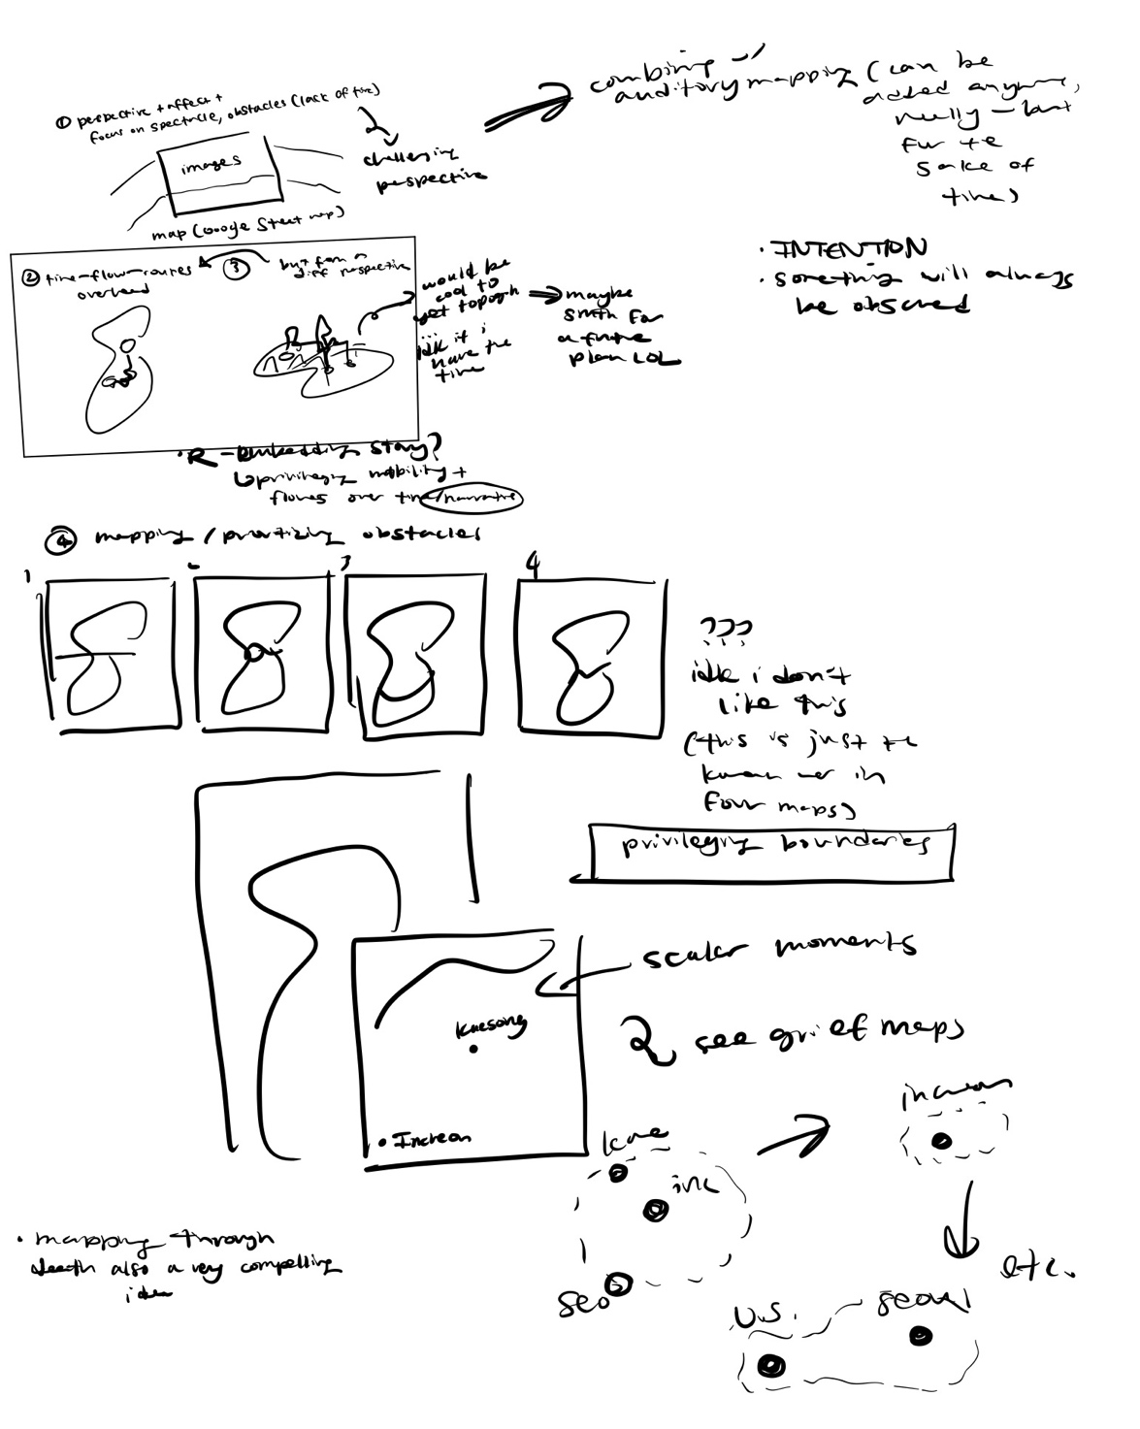
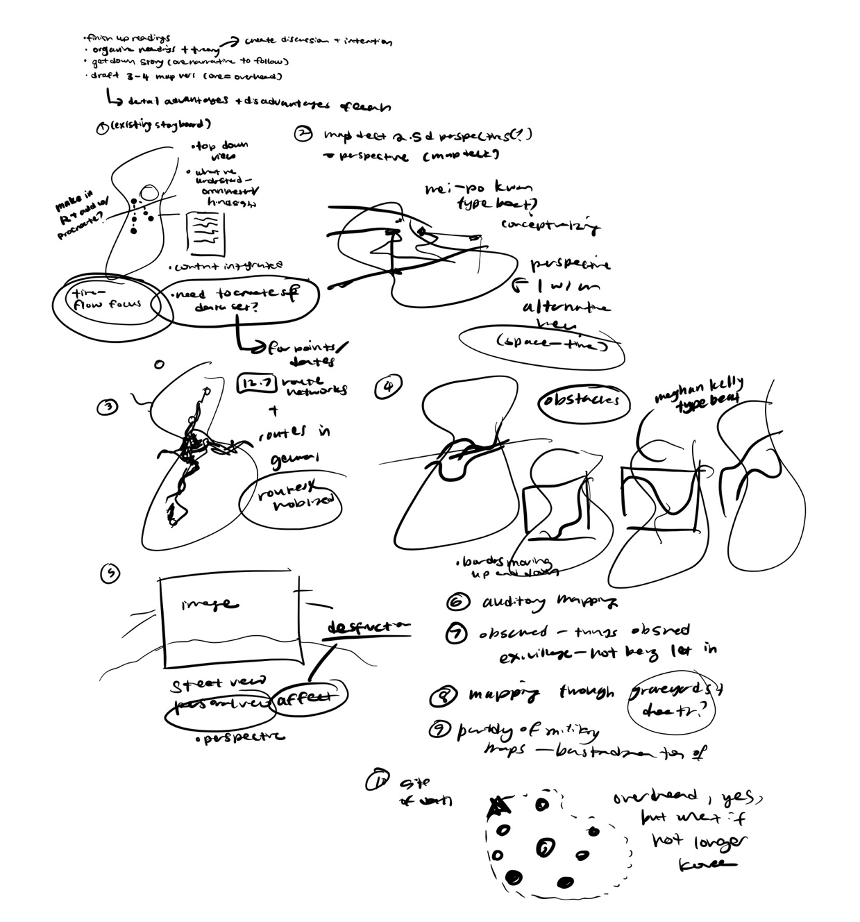

To cite a Korean proverb: 고래 싸움에 새우 등 터진다; in a fight between whales, it is the shrimp’s back that breaks.
Chun was separated from his family and faced the brunt of the conflict, being right on the 38th parallel, before eventually being forced to relocate to the U.S. after the division due to familial ties in the then-created DPRK; a common occurrence that drove Koreans out of their own land. His detailed story can be found in the Appendix (A).
See Appendix (B).
In making these maps, however, what most stuck with me was Chun Suntae’s own words (see Map 1). Perhaps, sometimes, the map need not speak for another.

